Thank You for purchasing a vermiculite board mold kit from OnGrade Studio.

- Prefire/burnout your pieces.
- Setup in kiln similar to this:

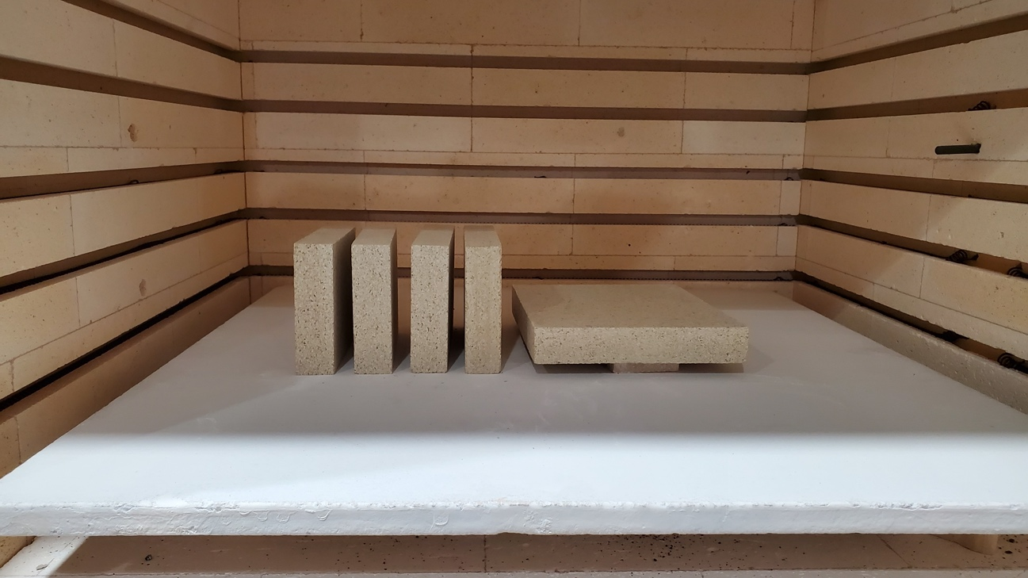

Or this:

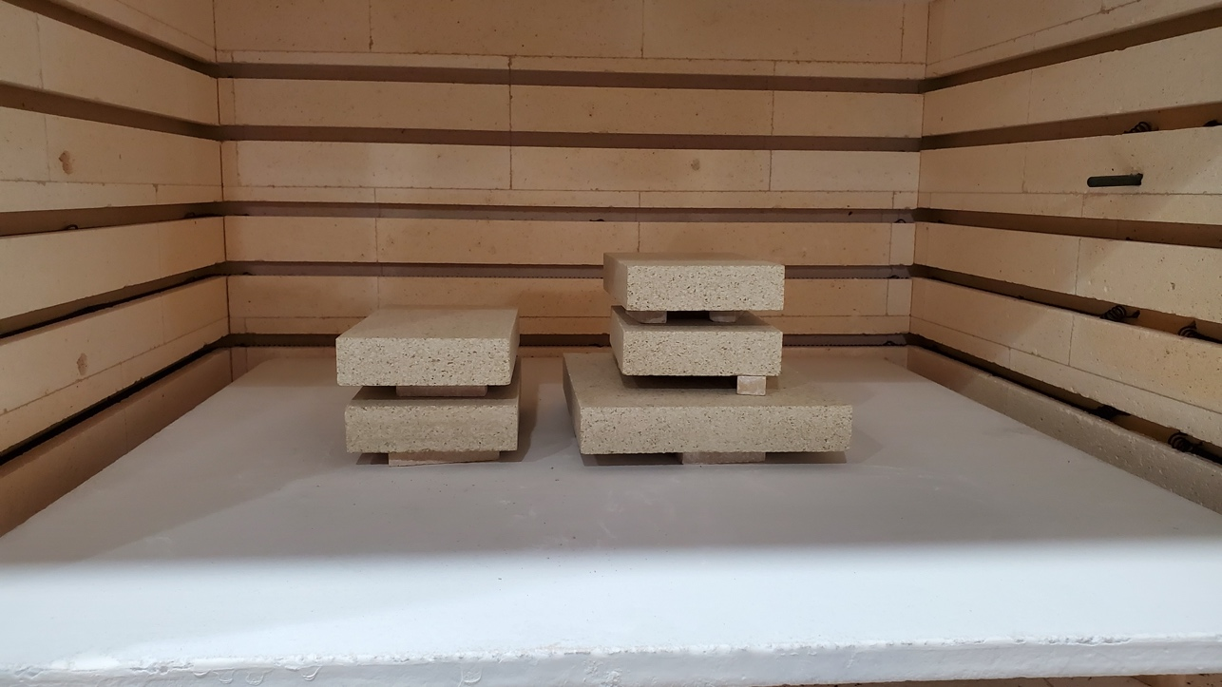

- Fire with vents open: 400dph to 1525F, hold :20 (It’s not a particularly sensitive firing. You could go faster. And a bit hotter, but above 1550 is unnecessary)

- Predrill holes using a drill bit slightly smaller in diameter than your 2” screws.

